# Introduction

The Danish Flexicurity model is well known worldwide, for being one of the most effective in keeping a low and stable unemployment rate compared to the other European countries. A key element in the flexicurity model is the generous unemployment benefits. Over the last couple of decades, the generosity of unemployment benefits has been decreasing in Denmark. One of the main measurements used to estimate the generosity is the compensation rate. The calculations of the compensation rate usually consist of the ratio between the average level of income insurance for those eligible to the average wage for employed. As can be seen in the figure bellow the compensation rate in Denmark has been falling since 1990-2020:

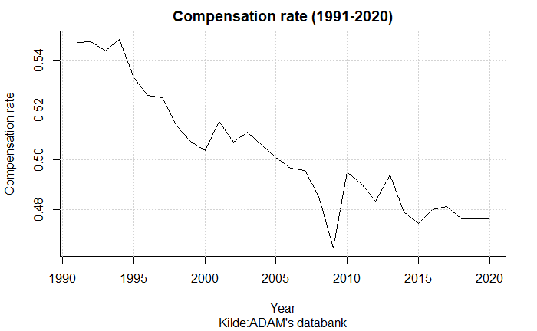

One of the major contributions to the falling compensation rate is the political regulations towards the determination of the maximum level of income insurance. In 2003 the Danish ministry of finance legislated a yearly regulation of unemployment benefits (xyz) one of the regulations goes through the rate regulation percent which is set to equal 2% each year added by the rate adjustment percent. The rate adjustment percent is each year set according to the adjustment percent which is calculated as the change in wages two years prior to the financial year subtracted by two percent points. If the adjustment percent is lower than 0%, the rate adjustment percent is equal to the adjustment percent. Is the adjustment percent between 0% and 0.3% the rate adjustment percent is 0%. Lastly, is the adjustment percent larger than 0.3% the rate adjustment percent is equal to the adjustment percent subtracted by 0.3 percent points. This creates a situation in which wage growth of more than 2% would result in the maximum level of income insurance not following the wage growth, making the compensation rate decline over time.

A more recent regulation is the one agreed upon in the Danish tax reform of 2014. One of the political initiatives in this reform was to suppress the regulations of employment benefits in the period of 2016-2023. Starting from 2016 the initiative would create a deduction of the rate regulation rate. The first year (2016) the deduction would be 0.3 percent points, next year 0.4 percent points and in period 2018-2023 0.75 percent points. (xyz)

Other studies discuss whether a third reason for a falling compensation rate should be included. Over time a larger share of the wage has been paid to the workers labor market pensions. When calculating the compensation rate the amount paid to labor market pensions from both the worker and employer is subtracted the wage. Therefor a larger share of the wage paid to labor market pensions will result in a lower rate of increase in the compensation rate. The argumentation for including the development in the share of the wage paid to labor market pensions is that employed will benefit from their pensions later in their lives.   
This third effect is not included in the graph showing the compensation over time, including this effect should up the rate of decrease and thereby make the fall in the compensation rate even larger.

Dagpengereformen

Nye dagpenge reform med “elitebilist princip”

This paper attempts to analyze the macroeconomic effects of unemployment benefits in a small open economy like Denmark. W

This paper makes three important contributions. First, we develop an empirical SFC-model integrating the dynamics of the Danish labor market, specifically including the variables that are used for political regulation of the unemployment benefits. Second, we do a counterfactual analysis of the regulations made towards the unemployment benefits. Third, this paper contributes to the ongoing debate of the effects of unemployment benefits on the level of unemployment.

The paper is organized as follows:

# Section 2: Lit review

**Beskæftigelses ministeriet:**

Det samlede billede er, at der over de seneste to årtier ikke er sket en væsentlig ”udhuling” af dagpengene – målt ved bruttokompensationsgraden – og dermed af den økonomiske tryghed i dagpengesystemet, når der ses på brede grupper på arbejdsmarkedet.

De beskriver de to effecter fra introduktionen med regulerings procenterne samt den stigende andel af lønenne der betales til arbejdsmarkedspensioner. De star ved at kompensationsraten er faldende grundet reguleringsprocenterne, men at det beløb derimod går til statspuljen.

De nedskyder effekten af arbejdsmarkeds pensioner, fordi at dagpenge er en forsikring der dækker indkomsttabet lige nu, og ikke en “livsforsikring”. Derudover vil folk der star udenfor arbejdsmarkedet på visse tidspunkter opnår andre ydelser som ældrecheck og vist også noget pensionstilskud en gang I mellem. Derfor mener de ikke der har været fald over tid I kompensationsraten

(Inkluderer ikke effekten af den på det tidspunkt kommende fald fra 2016-2023)

**DØR 2014:**

**LO:**

# Model description

The focus of this model is to analyze the effect of a change in the regulation of the maximum level of income insurance a person can receive after unemployment. To do so, we utilize the features of a stock-flow consistent framework and build upon the existing empirical stock flow consistent model for Denmark developed by (xyz). We contribute to the work of (xyz) by endogenizing the maximum level of income insurance. The dynamics of the model should be able to explain the macroeconomic effects of the change in the political regulations of the maximum income insurance. The next section will focus on the central equations added to include the new dynamics.

## Labor market equations

One of the key variables in the labor market is the participation rate, showing the ratio of the population being in the labor force. In the baseline model we keep this variable as exogenous, in the second scenario we will then remove this constraint and endogenize participation. A main reason for having the participation rare exogenous in the baseline model is that within the dynamics of the Danish labor market, many have failed to determine what brings people into the labor force. One of the mostly used explainers is the generosity of benefits for being outside the labor force compared with the wage (xyz). (xyz) also use the employment rate and argues that a raise in the employment rate would have brought some from standing outside the labor force to join it. As will be seen in the 2. Scenario these explainers are used to endogenizing the participation rate and thereby creating a new channel for changes in the maximum level of income insurance through a compensation rate.

The compensation rate later included in the equation for participation appears as an endogenous variable in the model estimated as the fraction of the average amount an unemployed on income insurance would receive (dp_person), to the average wage received given employment (wage_trim).



To calculate dp_person we use a simple ols regression linking the maximum level of income insurance to the average benefits received by unemployed eligible for income insurance. This is done as an alternative of using aggregated data of benefits received by households, as the gap between observed unemployment and estimated unemployment in the model is large, creating a lower average of benefits received. We also prefer the regression as we can capture the direct effect of an increased level of maximum income insurance but at the same time, we know that only around 85% eligible for income insurance receive the maximum level meaning that the increase for the people not getting the maximum level would be less. For this reason, we know that the coefficient should be between 0.85 and 1, and most likely closest to 1. This is also observed as the coefficient estimated is 0.9507 observed below.

Now, after defining how the maximum level of income insurance (max_dp) affects dp_person, we now define the equation for max_dp, the minestery of Finance will only calculate this once every year and the variable will therefor only change in the 1. Quarter and stay fixed for the rest of the year. In the baseline model “max_dp” follows the political regulations stated in the introduction. It follows that the maximum level of income insurance grows by the state regulation percentage plus the rate adjustment percentage Each year.

As the Ministry of Finance determine the state regulation percentage it is held exogenous in the model. On the other hand, the rate adjustment percentage is calculated each year, using the adaption percentage. To match what was explained in the introduction we need to set up three conditions: First, if the adaption percentage is lower than 0 rate adjustment percentage is equal to the adaption percentage. Second, if the adaption percentage is between 0.0 - 0.3% the rate adjustment percentage is set to 0. Third, if the adaption percentage is above 0.3% the rate adjustment percentage is equal to the adaption percentage minus 0.3% points.   
As with “max_dp” the rate adjustment percentage is calculated in the 1. Quarter and held fixed to the end of the year.

The adaption percentage is calculated by taking the wage growth two years before the financial year subtracted by 2% point, it should be noted that we use the yearly wage growth, which in the model is calculated using the 1. Quarter, therefor the adaption percentage is only calculated for 1. Quarter and held constant for the rest of the year.

The endogenization of “max_dp” is now completed within the model, and we can adjust the same variables as the Ministry of Finance when making regulations to the maximum level of income insurance. Max_dp is furthermore included in the wage equation, only having an impact on the wage in the short run.



# Validation of the model

We will in this section look at the performance of the model, comparing the results from the simulation with actual data, with a specific focus on the variables in the labor market.

In the below figures we compare the simulated and actual data for GDP, Employment, maximum level of income insurance and compensation rate.

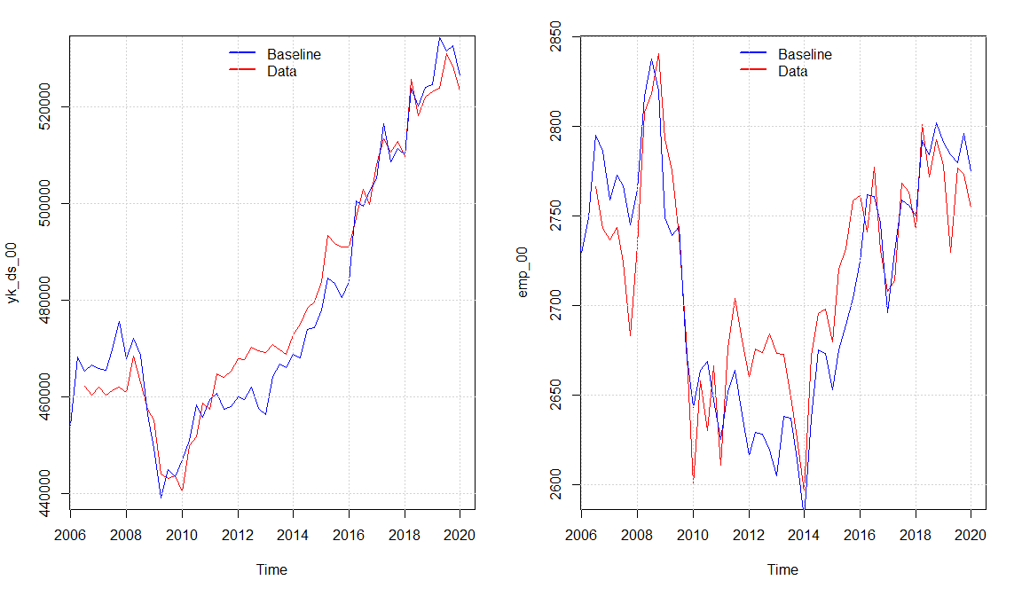

We observe that the model seems to capture the same dynamics of the real economy as (xyz) with a small overshooting in the economic activity in the period 2011 - 2016 explained by a higher simulated value of real investment and consumption compared with the data. Overall, the model seems to capture the medium to long-run tendency of the data even though there are some divergences in some quarters. The Overshooting in the activity also results in a higher level of the maximum level of income insurance in the baseline model, resulting from an increase in the wage growth. As the increase in wage growth goes directly into the compensation rate in the same period, meanwhile the maximum level of income insurance will be affected with a lag of 2 years, we observe that the compensation rate is a bit lower around 2010 - 2012, but as the adjustments happens it goes back to follow the real data.

In the next section We will look at two scenarios with different political regulations.

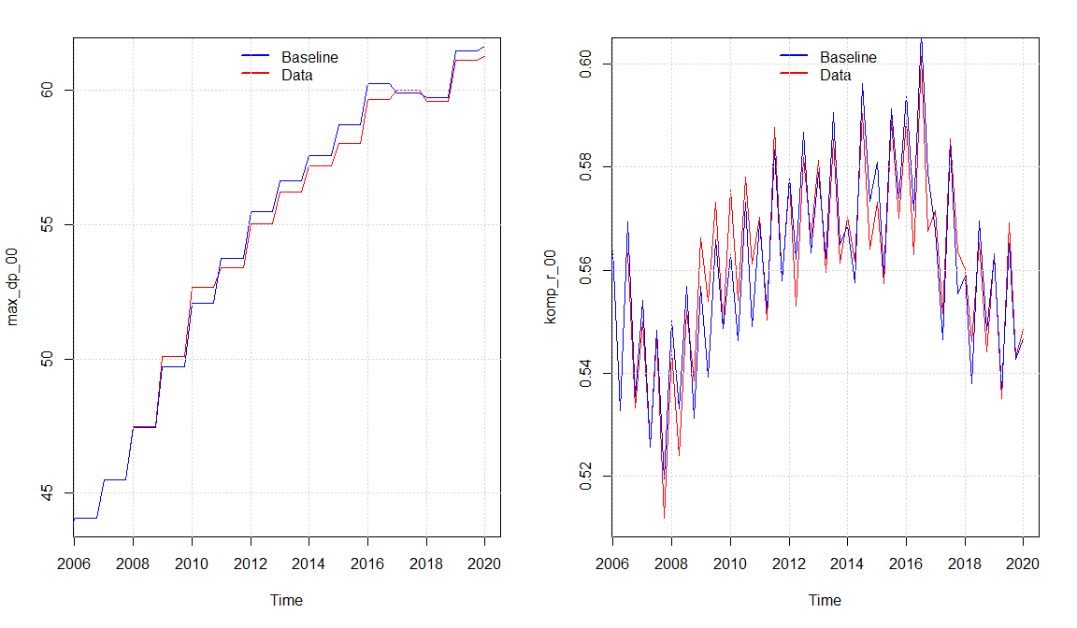

## Scenario 1 Wage adjustment in maximum level of income insurance

In this scenario we change the equation for the maximum level of income insurance, so that it follows the growth in wages from two years before the financial year. Therefore, this scenario will show the counterfactual situation in which the regulation from 2003 doesn’t appear, which means increases in the maximum level of income insurance will no longer be subtracted by up till 0.3% each time the growth in wages exceeds 2%. Also, the regulation from the 2014 tax reform is removed in this scenario. The new equation for the maximum level of income insurance takes the following form:



We keep using the wage growth two years before the financial year for consistency, as the (quit large) increases in 2003 and 2004 would inflate max_dp in the baseline but not in this scenario. As a result of the shock, we would expect max_dp to increase. As can be seen from the graph below max_dp increases by almost 6% from 2006q3 till 2020q1. We see that it is mostly coming of the removal of the suppressed adjustments in the unemployment benefits, isolating this effect can be observed from the last figure.

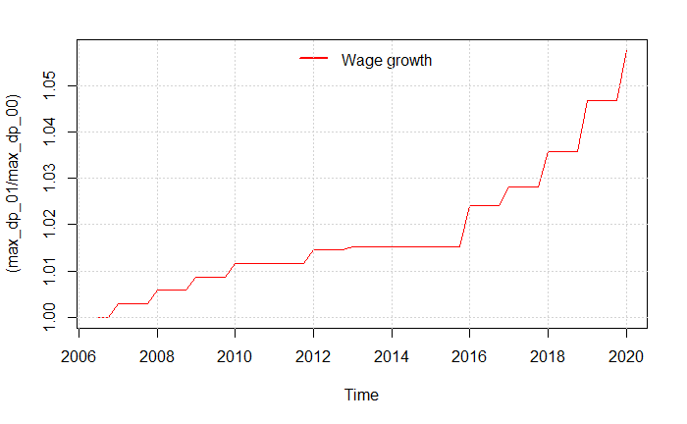

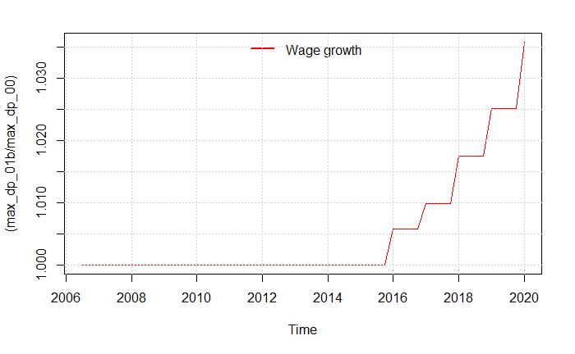

We can see that the increase in the maximum level of income insurance is quite large for those who are unemployed and eligible for this insurance. In comparison the macroeconomic consequence is minimal, in the figure below we can see….

Plot der viser det nærmest ingen effekt har på yk_ds og makro variable.

At the moment there are only two real effects of an increase in max_dp. First channel is the demand channel, as the larger max_dp results in a larger average level of income insurance which increases the disposable income for those receiving the income insurance and thereby increasing the economic activity.  
The second channel goes through the wages, as an increase in max_dp would require the employers to raise wages to attract workers, resulting in a positive relationship between max_dp and wage_ds in the model. The increase in wages will increase prices and lead to a contraction of the economy. In this scenario these two effects therefore seem to cancel each other out. In the second scenario we will perform the same shock defining max_dp as a function of the growth in wages two year prior to the financial year, but at the same time add a new channel threw endogenization of the participation rate

## Scenario 2 effect of maximum level of income insurance on participation

The endogenization of the participation rate happens with a few changes in the model. For now, the participation rate is exogenous and goes into the function defining the labor force as a fraction of the overall population.

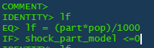

The development in the participation rate has over the years been “biased” as a result of an increasing ratio of older people in the population. Therefor, we created a new participation rate only looking at the population below 65 years of age. The difference in the two participation rates can be observed by the figure below.

We can see a difference in the trend of the two variables, where the participation rate of the population being younger than 65 years slopes upwards. Using this in the model with the explaining variables being the real wage, the compensation rate, and lastly the unemployment rate. This creates a new channel for max_dp to affect the economy as an increase in max_dp will raise the compensation rate. We find a positive relationship between the compensation-rate and participation-rate in both the long run and short run. The intuition is that people would rather stay in the labor force the higher the income insurance is compared to benefits when not searching for a job

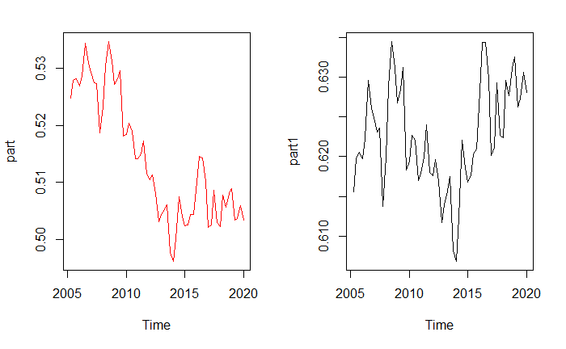

In the graph bellow we can observe the participation rate for the entire population before and after the endogenization of the participation rate, when performing scenario 1. We observe that the participation rate increases, as more people are actively searching for jobs when the level of income insurance is larger.

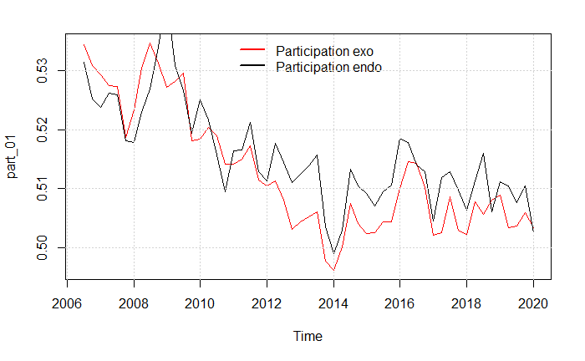

# Behavioral equations estimated

## Participation

## Wage_ds

